Application Demo Screenshot:

1. “start.java” class contains the main method

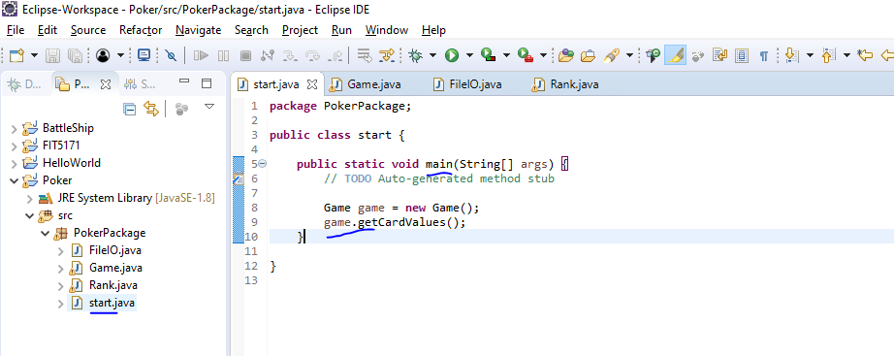

1. Click the “green”-> select “start” to run the application

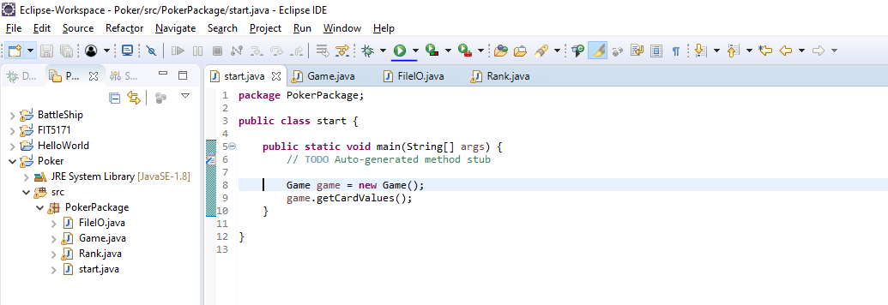

1. Writes the output in the gameoutcome.txt file in the same project folder

